**Personal Statement Workbook**

Congratulations on beginning your Personal Statement for your chosen health profession!

This workbook is designed to be a resource for you as you begin brainstorming and drafting your essay. This workbook will contain three parts (outlined below):

* Part 1: Values Assessment (Page 2-3)
* Part 2: Outline (Page 4-5)
* Part 3: First Draft (Page 6-7)

**You must complete AT LEAST one part of this workbook before submitting your self-assessment.** You will upload a copy of this workbook (with at least one completed part) to your self-assessment and will have the opportunity to review it with your PreHealth Advisor in your Application Readiness Meeting (ARM).

If you have any questions about the workbook, please contact your individual [PreHealth Advisor](https://undergraduate.northeastern.edu/prehealth/overview/staff/).

As you begin drafting your Personal Statement, you may find the following additional resources helpful:

* [Personal Statement Workshop](https://undergraduate.northeastern.edu/prehealth/personal-statement-workshop/)
* [Northeastern Writing Center](https://neu.mywconline.com/)
* [AAMC Core Competencies](https://students-residents.aamc.org/real-stories-demonstrating-premed-competencies/premed-competencies-entering-medical-students)

**Part 1: Values Assessment**

The Personal Statement serves many purposes in an application to a health profession program. In addition to providing additional information about the applicant, the Personal Statement serves as an opportunity for you to talk more about challenges you’ve overcome, your ambitions for pursuing your chosen health profession, why you decided to pursue various activities, professional goals, and much more.

Before you can tell other people what you feel is important, you must first reflect introspectively to identify which values and life principles are meaningful to you. Follow along with this values assessment to help you brainstorm potential themes for your Personal Statement.

**Step 1: Identify 3 Core Values**

*Select three values from the list below (or that you come up with on your own) that have been integral for you throughout your life.*

Values:

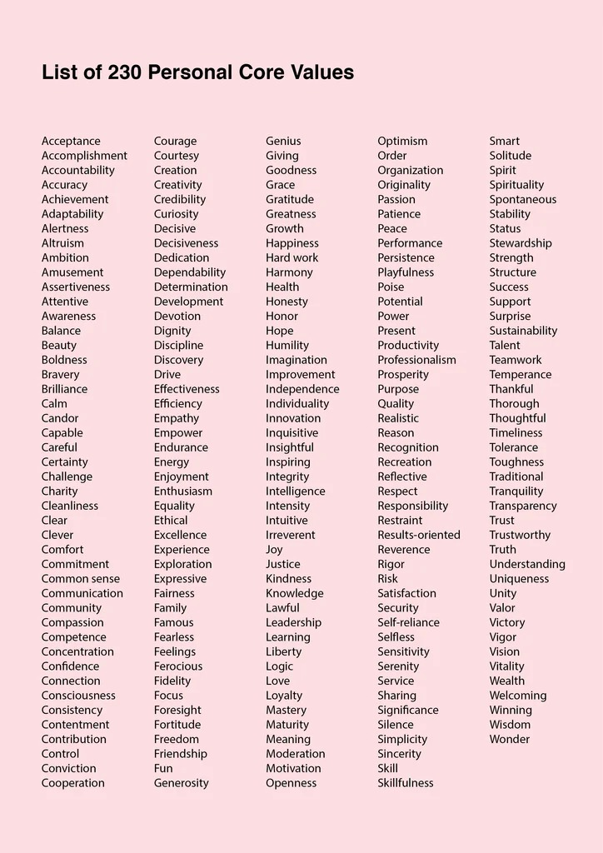

**Step 2: Reflect & Journal**

*Spend a few minutes reflecting on the three values you selected and answer the following questions:*

|  |  |
| --- | --- |
| *Question* | *Response* |
| How did you choose these values? |  |
| Why are these values important to you? |  |
| How will you use these values to help you achieve your goals and/or in your daily practice as a provider? |  |
| Can you think of examples in your life that personify these values? |  |

**Step 3: Continue Reflecting**

*Reflect on your answers to the questions in the previous step. Use the space below to identify 1-2 patterns or themes you noticed in your responses.*

|  |  |
| --- | --- |
| *Theme 1* | *Theme 2* |
|  |  |

* Do either of these themes represent your motivation for your future health profession?
* Would a Personal Statement focusing on one of these themes give an admissions committee deeper insight into who you are?

Continue reflecting on this throughout the application cycle! Consider keeping a journal!

**Part 2: Outline**

**Step 1: Brainstorm**

*Use this space to reflect on why and how you’ve decided to be a practitioner in your chosen health profession. What has drawn you to this field?*

|  |  |
| --- | --- |
| *Activities that can help you Brainstorm* | *Brainstorm* |
| 1. Conduct a Values Assessment (previous step) 2. Thoughtfully Reflect and Journal about instances that have been particularly impactful for you (both positively and negatively) |  |

**Step 2: Establish a Theme**

*Once you’ve finished brainstorming, try to find patterns within your reflections, and condense your motivations for your chosen career into 1-2 sentences.*

|  |  |
| --- | --- |
| *Identify Patterns you found in your reflections* | *1-2 Sentence Theme* |
|  |  |

**Step 3: Draft Introduction Paragraph**

*Once you’ve identified your theme, you can begin drafting your essay – starting with the introduction!*

|  |  |
| --- | --- |
| The most memorable personal statements begin with a thoughtful introduction. Try to think about an example from your past (from either a personal or professional setting) that embodies the theme you established in Step 2.  *For example: If your theme centers around advocacy, think about a time you advocated for someone (including yourself).* | Use this space to outline your opening story: |
| Use the last 1-2 sentences of your introduction to connect your opening story to why you want to be a provider. This will include introducing your theme and setting up the rest of the essay. | Introduce Theme: |

**Step 4: Draft 2-3 Supporting Evidence Paragraphs**

*Once you’ve introduced the reader to why you want to be a provider, it is time to back up your claims with supporting evidence. The next 2-3 paragraphs should provide instances/examples from the present (or recent past) that exemplify your theme.*

|  |  |
| --- | --- |
| *Example* | *Reflect on how this relates to the theme* |
|  |  |

|  |  |
| --- | --- |
| *Example* | *Reflect on how this relates to the theme* |
|  |  |

|  |  |
| --- | --- |
| *Example (Optional)* | *Reflect on how this relates to the theme (Optional)* |
|  |  |

**Step 5: Conclusion**

*Use this space to recap what you’ve learned and to give the reader a look into your future as a provider.*

|  |  |
| --- | --- |
| Recap what you’ve presented thus far. What have you learned about yourself in the process? How do all these examples and experiences relate back to your theme?  The conclusion should *not* introduce new stories or new information. | Recap: |
| End your Personal Statement with a call to action. How will these experiences shape the provider you will become in the future? | Call to Action: |

**Part 3: First Draft**

*Identify the prompt of your chosen health profession (below) and use the space below to compose a first draft for your PreHealth Advisor to review.*

|  |  |  |
| --- | --- | --- |
| *Application Service/Profession* | *Prompt* | *Character Limit* |
| AMCAS (MD) | Use the space provided to explain why you want to go to medical school.​ | 5300 characters |
| AMCAS: MD/PhD Essay  *\*MD/PhD Applicants Only* | Use the MD/PhD Essay to state your reasons for pursuing the combined MD/PhD degree. | 3,000 characters |
| AMCAS: Significant Research Experience Essay  *\*MD/PhD Applicants Only* | In addition to the MD/PhD Essay, you are required to write an essay that describes your significant research experiences. In this essay, please specify your research supervisor's name and affiliation, the duration of the experience, the nature of the problem studied, and your contributions to the research effort. | 10,000 characters |
| AACOMAS (DO) | In the space provided write a brief statement expressing your motivation or desire to become a DO. Keep your statement general as the same essay will be sent to all schools you will apply to.​ | 5300 characters |
| ADEA AADSAS (Dental)​ | Your personal statement is a one-page essay that gives dental schools a clear picture of who you are and, most importantly, why you want to pursue a career in dentistry.​ | 4500 characters |
| CASPA (PA) ​ | This section is where you can write a brief statement expressing why you are interested in being a Physician Assistant.​ | 5,000 characters |
| OPTOMCAS (Optometry)​ | Please describe what inspires your decision for becoming an optometrist, including your preparation for training in this profession, your aptitude and motivation, the basis for your interest in optometry, and your future career goals.​ | 4,500 characters |
| VMCAS (Veterinary)​ | Your personal statement is a one-page essay that gives veterinary admissions committees a clear picture of who you are and, most importantly, why you want to pursue a career in veterinary medicine.​ | 3,000 characters |
| AACPMAS (Podiatry)​ | This section is where you can write a brief statement expressing why you are interested in becoming a Doctor of Podiatric Medicine. Provide information about your development for a career in Podiatric Medicine.​ | 4,500 characters |
| TMDSAS (MD/DO)​  *\*Texas Schools Only* | The personal essay asks you to explain your motivation to seek a career in medicine. You are asked to include the value of your experiences that prepare you to be a physician.​ | 5000 characters |
| TMDSAS (Dental)​  *\*Texas Schools Only* | The personal essay asks you to explain your motivation to seek a career in dentistry. You are asked to discuss your philosophy of the dental profession and indicate your goals relevant to the profession.​ | 5000 characters |
| TMDSAS (Veterinary)​  *\*Texas Schools Only* | The personal essay asks you to describes opportunities and challenges (veterinary-related and non-veterinary-related) you have experienced and how these have helped to prepare you to enter the veterinary profession.​ | 5000 characters |

|  |
| --- |
| *Draft* |
|  |